<Draft>

Research activities plan: health benefits navigation

Project overview

Research goals

Hypotheses

Research impact

Research plan and method

Estimated research timeline

Recruiting criteria

Logistics

Dependencies/other things to note

Research deliverables

Previous research

## Project overview

Veterans find it extremely difficult to navigate commonplace interactions with the VA. The VA ecosystem is so complex that Veterans feel discouraged to apply for, manage, and maximize their benefits.

This experience extends online. There is a fragmentation in information and tools. In particular, navigating between general information and personalized information and tools is difficult. Veterans (will) come to VA.gov to learn what benefits are available to them, apply, and then track and manage those benefits. While these are distinct stages, we expect that Veterans will need to continue learning about their benefits during the application process, and when managing their benefits.

## Research goals

How might we create an experience that allows Veterans to easily find the content and tools they need based on where they are in their VA healthcare journey: learning about the benefit, applying for the benefit, getting started with the benefit, or managing their care and health benefits?

* How might Veterans navigate between and complete core tasks in ‘get benefits’ and ‘manage benefits’ on VA.gov?
* How might the unauthenticated (not signed in) and authenticated (with or without healthcare) experiences flow for ‘get benefits’ and ‘manage benefits’
* Determine where the Health Apartment will live on VA.gov

### Hypotheses

Our first two hypotheses are provided by the Health Apartment and Health Hub teams.

**Hypothesis 0:** There is one place to get benefits and manage benefits (both sets of information are essentially in one unified section)

**Hypothesis 1:** Healthcare tasks should live in two separate sections of VA.gov: ‘get benefit’ (which is currently the Health Hub) and ‘manage benefit’ (which is the proposed Health Apartment).

## Research impact

Our findings will inform how the Health Apartment figures into VA.gov, and how a Veteran will manage their health benefits on the site.

* Veterans maximize their health care benefits, especially those from underserved communities
* Veterans find it easy to manage their health care on VA.gov
* More Veterans go to VA.gov to manage their healthcare tasks

## High-level plan

We expect this plan sequence and methods to change as we learn. Plans are useless, planning is invaluable.

* Conduct interviews with business partners across OCTO to learn their perspectives and needs
* Create an experience map for Veterans initially based on secondary research, and later refined with primary research conducted with Veterans
* Conduct tree tests (to validate site map associated with hypotheses 0 and 1). If neither hypothesis emerges as a clear winner, we’ll go back to the drawing board with a card sorting activity to inform a new IA
* Conduct interviews with Veterans and caregivers to understand their experiences, pain points, and moments of delight along their healthcare “journey.”
* Create low-fidelity wireframes with navigation
  + Design studio with the broader team
  + Conduct usability tests with Veterans and caregivers
* Create higher fidelity prototypes to evaluate navigation, content, and design
  + Conduct usability tests with Veterans and caregivers
* Synthesize results and socialize

## Recruiting criteria

We will conduct research with Veterans and caregivers. The exact number of research participants will vary depending on the test, but in general, here are the populations and sub-groups we’ll target:

### Veterans

* Have VA health care benefits and regularly use MyHealtheVet
* Have VA health care benefits and do not use MyHealtheVet
* Do not have VA health care benefits
* Are new to VA health care benefits
* Have other VA benefits but not health care
* From under-served communities
* Veterans with cognitive impairments

### Caregivers

* Participants who are caregivers to Veterans and/or their dependents accessing VA benefits

### Resources

* These Veteran and caregiver [personas](https://github.com/department-of-veterans-affairs/va.gov-team/blob/master/platform/design/va-customer-personas/VA%20Customer%20Personas.pdf) might help us with recruitment and research
* The [Veteran Journey Map](https://github.com/department-of-veterans-affairs/va.gov-team/blob/master/platform/design/va-product-journey-maps/Veteran%20Journey%20Map.pdf) will also help us design research for specific points along a Veteran’s health journey

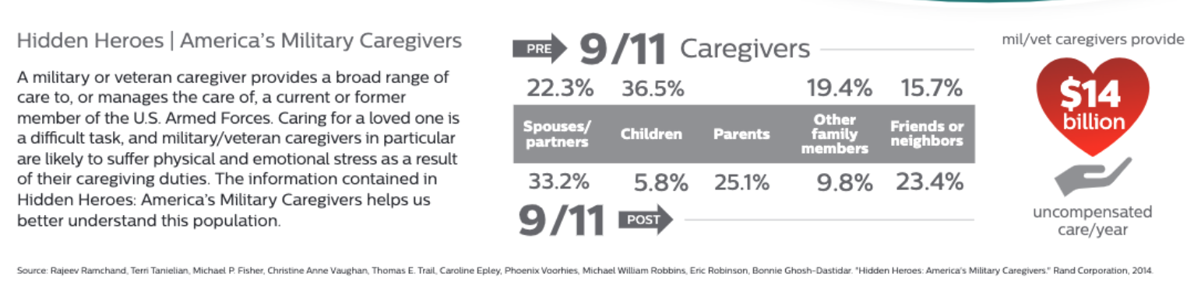

*Image from* [*Caregiver Journey Map*](https://github.com/department-of-veterans-affairs/va.gov-team/blob/master/platform/design/va-product-journey-maps/Caregiver-Journey-Map.pdf)

## Logistics

Tools

* Optimal Workshop
* Sketch
* Mural
* Zoom

Recruiting

* Perigean

## Dependencies

We’ll need to stay aligned with our counterparts at the VA as they continue to think through the information architecture as well. We’ll also hold periodic workshops with VA business owners to socialize our findings and gain buy-in for our recommendations

## Research deliverables

1. Research syntheses
   1. A summary of our findings for each research activity, including key takeaways, in-depth analyses, recommendations, and considerations for further research
2. Prototypes
   1. What exactly this will look like is to be determined, but we will deliver a visual prototype, validated by user testing, of the health hub.